**Practical-8**

**Aim: Write a Program Using 8085 & Verify for:**

1. Subtraction of Two 8-Bit Numbers. (Display Of Borrow)

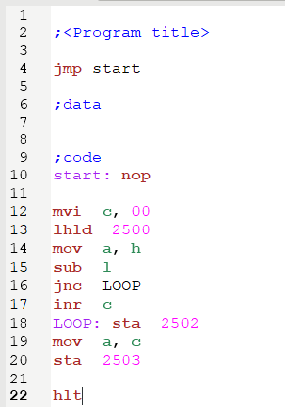 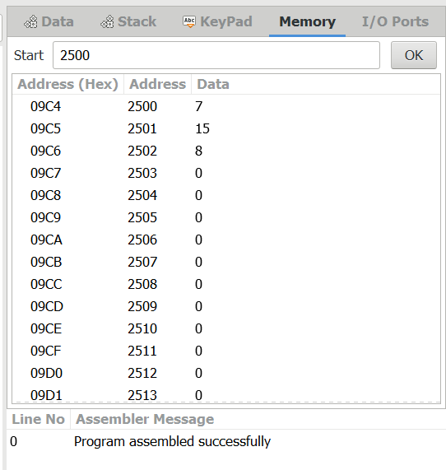

1. Subtraction of Two 16-Bit Numbers. (Display Of Borrow)

